**DEVELOPMENT OF WEB-BASED E-LEARNING SYSTEM**

**BY**

**OYEMADE OLUWAYIMIKA RUFUS (080958)**

**AND**

**ABAYOMI DAMILOLA ()**

**BEING A JOURNAL**

**SUBMITTED TO THE**

**DEPARTMENT OF COMPUTER SCIENCE AND ENGINEERING**

**LADOKE AKINTOLA UNIVERSITY OF TECHNOLOGY,**

**OGBOMOSHO, NIGERIA**

**SEPTEMBER, 2014**

**ABSTRACT**

E-learning broadly includes all form of educational technology to create experiences that educate our fellow human beings which is synonymous with multimedia learning, technology-enhanced learning, computer-based instruction etc. The project titled DEVELOPMENT OF WEB-BASED ELEARNING SYSTEM aims to use the internet as a medium of teaching and learning which could be accessible via smart devices.

Using the approach of a lecturer being the content author and the student as the content user, the project was created using web development tools such as DreamWeaver, PHP as the scripting language and MySQL for the data repository.

The result of this project is a practical example of custom-built E-learning system that has to two portals; one for the lecturers and the other for the students through which they can have access to the system anytime anywhere.

The application is a complete web application in its entirety and given adequate internet access and technological policies it will be a great avenue for distance learning in Nigeria.

**INTRODUCTION**

When it comes to education, the model has been pretty straight forward - up until the early 2000s, education was in a classroom of students with a teacher who led the process. Physical presence was a requisite, and any other type of learning was questionable at best. Then the internet happened and education was redefined.

Now that affordable solutions exist for both computers and internet, it only takes a good E-learning tool for education to be facilitated from virtually anywhere. Technology has advanced so much that the geographical gap is bridged with the use of tools that make one feels as though one is inside classroom. E-learning offers the ability to share material in all kinds of formats such as videos, slideshows, word documents and PDFs. Conducting webinars (live online classes) and communicating with professors via chat and message forums is also an option available to users.

With the right tool, various processes can be automated such as a course with set materials and automatically marked tests. E-learning is an affordable (and often free) solution which provides the learners with the ability to fit learning around their lifestyles, effectively allowing even the busiest person to further a career and gain new qualifications.

**METHODOLOGY**

The e-learning platform called “VirtualClass!” is developed using PHP which is embedded in HTML codes. The platform is designed with much consideration on security issues to avoid unauthorised users to obtain documents or lecture notes or unauthorised persons login through the admin login section. The web application which is currently hosted on localhost is developed using Content Management System (CMS) approach in which the lecturers are the content creator and the students as the content user/consumer.

To achieve this, the platform is thus divided into two distinct sections namely:

1. Student Section
2. Lecturer/Administration Section

The database “elearn_db” was created using the MySQL server 5.6.12. Various tables which hold related data in the database were also created. PHP 5.4.14 interpreter was installed to interpret PHP codes before it will send the PHP codes and HTML codes to the web browser to display. Apache HTTP Server 2.4.4 was installed to serve the web server that will serve any web page being requested by the client. The front-end/client interface is developed with Adobe Dreamweaver. It has a number of web pages ending in .php linked together. The user program can be deployed from any machine once hosted since it is meant to run a browser.

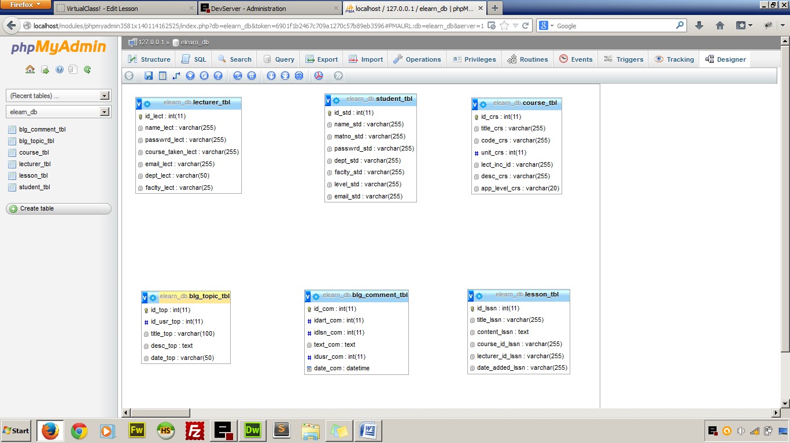

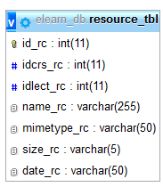

Figure 1 Entity Relationship Diagram of the Database

# RESULT AND DISCUSSION

## STUDENT SECTION

After a successful log in the user is redirected to the student’s homepage where resources can now be accessed because of the active log in. The homepage is characterised by a brief history of what the student can do with the web application. The homepage also have a list of the recent lecture materials that was added to the database by the lecturers and below the page is the details of the logged in student such as full name, department, faculty, matriculation number and current level.

**Courses**

When the student clicks on course from the main menu, he/she is redirected to the page that contains all the registered courses with a brief introduction to each course, course code and unit, the lecturer-in-charge and the number of lessons under each courses. Clicking the course title takes the student to the page that contains all the lessons under the course starting from the latest to the oldest. This helps students to read only the latest lesson notes first.

**Resources**

This section contains all the uploaded media documents added by the lecturers that can be viewed online or downloaded for offline reading as the case may be. The managers (the lecturers) have the privilege to upload a document, audio or video.

**Forum**

Discussion is carried out within the e-learning system here. Students can ask question based on anything and get their colleagues to discuss any trending issue. The lecturers serve as the Forum Moderator that delete or block any irrelevant forum topic.

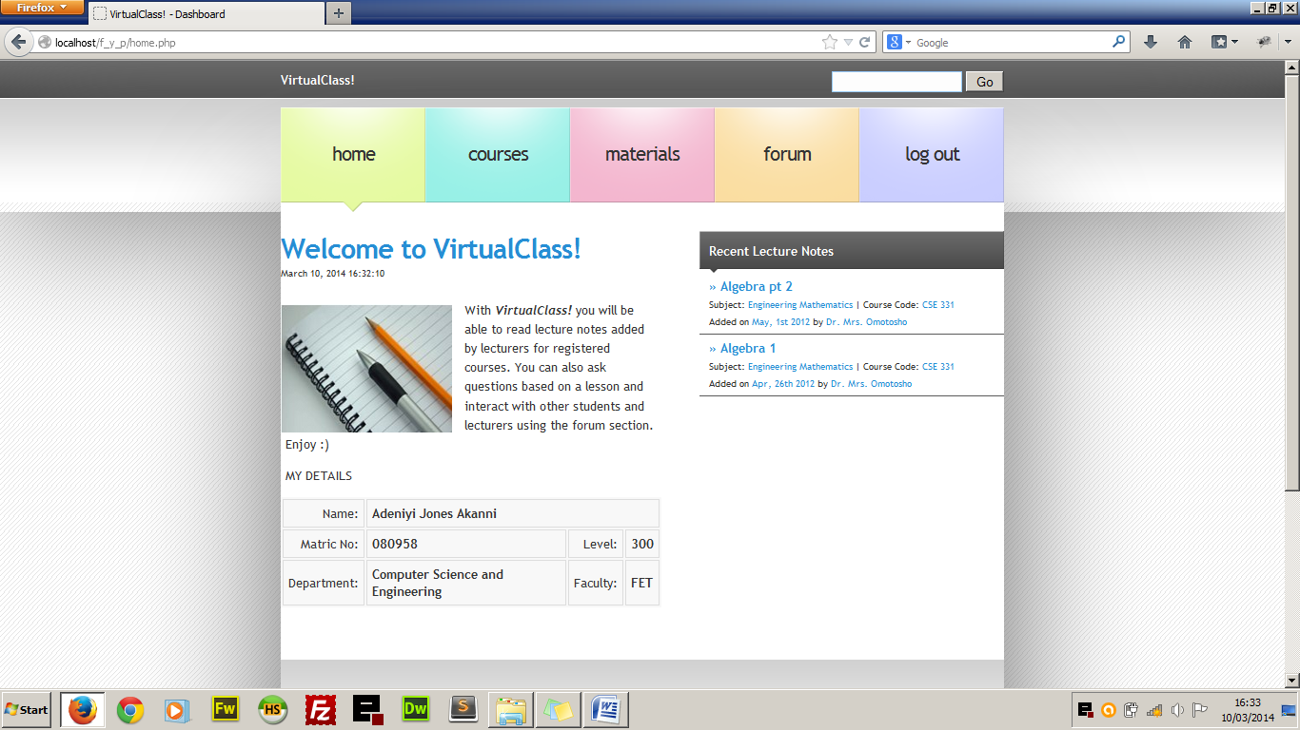

Figure 4.2 Student Home Page

**LECTURER/ADMIN SECTION**

The lecturer section is where the links to manage the courses lies and it can only be accessed using username and password given to lecturers. The username in the case of the lecturer is the email address of the lecturer and a predefined password. The lecturers’ section contains the tools in three subsections which include:

1. Course Lesson Management
2. Course Material Management
3. Forum Management

## Course Lesson Management

The lecturer is able to manage only the course which he is assigned to. Management in the sense that lecturers will be able to add lesson notes to their courses, edit the lesson notes as the case may be and delete the lesson note if necessary. They will also be able to see comments posted by students to each lessson and reply if it is a question or delete from the database if it is a profane comment.

## Course Resources Management

Lecturers using the web application will be able to upload files which could be normal documents or audio visual files that could help the student further in their studies. Lecturers are granted the privilege of adding and deleting as the case maybe. The uploaded material is bounded with the course that the lecturer is taking.

## Forum Management

We cannot deny the fact that there are always excesses when it comes to student giving reviews and comments and this is why lecturers are given the role of managing the discussion forum. They are given the privilege of deleting forum topics that are not educational and also delete comments that are irrelevant to ongoing discussion.

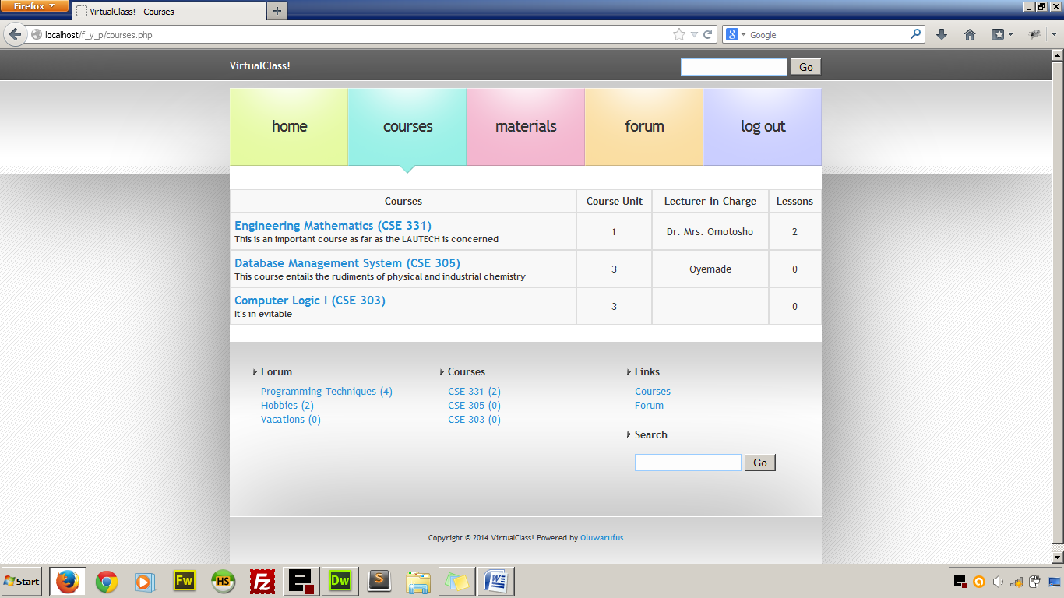

Figure 2 Leturer’s course management page

# CONCLUSION AND RECOMMENDATION

CONCLUSION

Conventional teaching system is still favourable in the tertiary educational system in Nigeria but a handful of universities have embraced online lecture delivery system in order to synchronize lectures and courseware materials for their distant learning students and for their in-campus students. The adoption of online synchronisation of lecture materials will adequately supplement the conventional face-to-face teaching system; most lecturers will find it easy to run online version of their courses and at the same time deliver face-to-face lectures at their convenience. For instance, in a course where most of the required materials have been given beforehand online, the lecturer will only need a class or two to explain course contents which will ordinarily take them eight to ten classes to explain. On the other hand, students will acclimatize quickly on the online environment and with formal adoption of this lecturing system, they will learn quickly and more efficiently.

The project is practical example of custom-built E-learning system that supports the academic curriculum in use in Nigeria. It is built to support integration with other educational web application such as online grading systems which could be deployed with it as the need be.

## 5.2 RECOMMENDATIONS

For smooth and effective online lecture delivery, the stake holders in the educational sector such as the governments, school management boards, parents, etc. are hereby enjoined to provide the following:

1. Adequate infrastructural facilities in universities to support online lecture delivery.
2. Adoption of the online learning system as part of the learning structures in the federation
3. Encouragement to students by making available affordable computer devices as well as internet connectivity.
4. Establishment of favourable technological policies that will increase the rate of ICT adoption.

# REFERENCES

Arbaugh, J.B., and Duray, R. (2002). Technological and Structural Characteristics, Student Learning and Satisfaction With Web Based Courses. Management Learning, Vol.3, Pp 1-15.

Arison, D., and Cuthbertson, C., (2002), Management Approach to Database Application [In A Relational Environment], McGraw-Hill, Vol.34, No.3, Pp 34-38

Barkan, M., and Ozad, B Open Learning: The Way Ahead. Paper Presented In the First Open Learning Symposium, Esksehir, Turkey.

Institute for Higher Education Policy. (1999). What's the Difference? A Review of Contemporary Research On The Effectiveness of Distance Learning In Higher Education.

Johnson, S. D., Aragon, S. R., Shaik, N., and Palma-Rivas. N., (2000).Comparative Analysis of Learner Satisfaction and Learning Outcomes in Online and Face-to-Face Learning Environments. Journal of Learning Research, Vol. 11, No. 1, Pp 29-50.

Lewis B. A. and Macentee, V. M., (2005). Learning Management System Comparison, Informing Science and It Education Joint Conference, Vol. 1 No. 2, Pp 1-15

Rengarajan, R., (2001). LCMS and LMS: Taking Advantage of the Tight Integration. Internal Journal of E-Learning, Vol. 16. Pp 57-65.

Russell. T., (1999). The No Significant Difference Phenomenon, office of Instructional Telecommunications, North Carolina State University.

Sampson,N., (2003). Meeting the Needs of Distance Learners. Language, Learning, and Technology, Vol.7, Pp 103-126.

Willett, H. G., (2002). Not One of the Other but Both: Hybrid Course Delivery Using WebCT. The Electronic Library, Vol. 20, No. 5, Pp 413-419